스마트폰프로그래밍

Assign #5

(과제명 : IntentTest1 연습)

학번 : 2013305019

성명 : 김 지 민

제출일자 : 2017. 10. 19

본인은 타인이나 다른 매체를 도용하지 않았음을 확인합니다 <본인사인>

MainActivity.java

**package** com.example.kimji_min.assignment5;  
  
**import** android.content.Intent;  
**import** android.os.Bundle;  
**import** android.support.v7.app.AppCompatActivity;  
**import** android.view.View;  
**import** android.widget.Button;  
  
**public class** MainActivity **extends** AppCompatActivity {  
  
 @Override  
 **protected void** onCreate(Bundle savedInstanceState) {  
 **super**.onCreate(savedInstanceState);  
 setContentView(R.layout.***activity_main***);  
  
 Button button1 = (Button) findViewById(R.id.***button1***);  
 Button button2 = (Button) findViewById(R.id.***button2***);  
 Button button3 = (Button) findViewById(R.id.***button3***);  
 Button button4 = (Button) findViewById(R.id.***button4***);  
  
  
 button1.setOnClickListener(**new** View.OnClickListener() {  
 @Override  
 **public void** onClick(View view) {  
 Intent in = **new** Intent(MainActivity.**this**, SubActivity1.**class**);  
 startActivity(in);  
 }  
 });  
  
 button2.setOnClickListener(**new** View.OnClickListener() {  
 @Override  
 **public void** onClick(View view) {  
 Intent in2 = **new** Intent(MainActivity.**this**, SubActivity2.**class**);  
 startActivity(in2);  
 }  
 });  
 }  
}

SubActivitiy1.java

**package** com.example.kimji_min.assignment5;  
  
**import** android.os.Bundle;  
**import** android.support.v7.app.AppCompatActivity;  
**import** android.view.View;  
**import** android.widget.Button;  
  
*/**  
 * Created by Kim Ji-min on 2017-10-14.  
 */***public class** SubActivity1 **extends** AppCompatActivity {  
 **public void** onCreate(Bundle savedInstanceState){  
 **super**.onCreate(savedInstanceState);  
 setContentView(R.layout.***sub1***);  
  
 Button button3 = (Button)findViewById(R.id.***button3***);  
 button3.setOnClickListener(**new** View.OnClickListener() {  
 @Override  
 **public void** onClick(View view) {  
 finish();  
 }  
 });  
 }  
}

SubActivity2.java

**package** com.example.kimji_min.assignment5;  
  
**import** android.os.Bundle;  
**import** android.support.v7.app.AppCompatActivity;  
**import** android.view.View;  
**import** android.widget.Button;  
  
*/**  
 * Created by Kim Ji-min on 2017-10-14.  
 */***public class** SubActivity2 **extends** AppCompatActivity {  
 **public void** onCreate(Bundle savedInstanceState){  
 **super**.onCreate(savedInstanceState);  
 setContentView(R.layout.***sub2***);  
  
 Button button4 = (Button)findViewById(R.id.***button4***);  
 button4.setOnClickListener(**new** View.OnClickListener() {  
 @Override  
 **public void** onClick(View view) {  
 finish();  
 }  
 });  
 }  
}

activity_main.xml

*<?***xml version="1.0" encoding="utf-8"***?>*<**LinearLayout xmlns:android="http://schemas.android.com/apk/res/android"  
 xmlns:app="http://schemas.android.com/apk/res-auto"  
 xmlns:tools="http://schemas.android.com/tools"  
 android:layout_margin="5pt"  
 android:layout_width="match_parent"  
 android:layout_height="match_parent"  
 android:orientation="vertical"  
 tools:context="com.example.kimji_min.assignment5.MainActivity"**>  
  
 <**LinearLayout  
 android:layout_width="match_parent"  
 android:layout_height="wrap_content"  
 android:background="@drawable/border"**>  
 <**Button  
 android:id="@+id/button1"  
 android:layout_margin="3pt"  
 android:layout_width="60pt"  
 android:layout_height="45pt"  
 android:background="@drawable/starry_night"**/>  
 <**LinearLayout  
 android:layout_width="wrap_content"  
 android:layout_height="wrap_content"  
 android:orientation="vertical"**>  
 <**TextView  
 android:layout_gravity="end"  
 android:layout_width="wrap_content"  
 android:layout_height="wrap_content"  
 android:text="Starry Night"** />  
 <**TextView  
 android:layout_width="wrap_content"  
 android:layout_height="wrap_content"  
 android:text="고흐"**/>  
 </**LinearLayout**>  
 </**LinearLayout**>  
  
 <**LinearLayout  
 android:layout_width="match_parent"  
 android:layout_height="wrap_content"  
 android:background="@drawable/border"**>  
 <**Button  
 android:id="@+id/button2"  
 android:layout_margin="3pt"  
 android:layout_width="60pt"  
 android:layout_height="45pt"  
 android:background="@drawable/still_life_with_kettle"**/>  
 <**LinearLayout  
 android:layout_width="wrap_content"  
 android:layout_height="wrap_content"  
 android:orientation="vertical"**>  
 <**TextView  
 android:layout_gravity="end"  
 android:layout_width="wrap_content"  
 android:layout_height="wrap_content"  
 android:text="Still Life with Kettle"** />  
 <**TextView  
 android:layout_width="wrap_content"  
 android:layout_height="wrap_content"  
 android:text="폴 세잔"**/>  
 </**LinearLayout**>  
 </**LinearLayout**>  
  
</**LinearLayout**>

sub1.xml

*<?***xml version="1.0" encoding="utf-8"***?>*<**LinearLayout xmlns:android="http://schemas.android.com/apk/res/android"  
 android:layout_width="match_parent"  
 android:layout_height="match_parent"  
 android:orientation="vertical"** >  
 <**Button  
 android:id="@+id/button3"  
 android:layout_width="match_parent"  
 android:layout_height="wrap_content"  
 android:textColor="@color/red"  
 android:text="Starry Night"**/>  
 <**TextView  
 android:layout_margin="5pt"  
 android:layout_gravity="right"  
 android:layout_width="wrap_content"  
 android:layout_height="wrap_content"  
 android:textColor="@color/green"  
 android:text="고흐"**/>  
 <**TextView  
 android:layout_width="wrap_content"  
 android:layout_height="wrap_content"  
 android:background="@drawable/starry_night"**/>  
</**LinearLayout**>

sub2.xml

*<?***xml version="1.0" encoding="utf-8"***?>*<**LinearLayout xmlns:android="http://schemas.android.com/apk/res/android"  
 android:layout_width="match_parent"  
 android:layout_height="match_parent"  
 android:orientation="vertical"** >  
 <**Button  
 android:id="@+id/button4"  
 android:layout_width="match_parent"  
 android:layout_height="wrap_content"  
 android:textColor="@color/red"  
 android:text="Still Life with Kettle"**/>  
 <**TextView  
 android:layout_margin="5pt"  
 android:layout_gravity="right"  
 android:layout_width="wrap_content"  
 android:layout_height="wrap_content"  
 android:textColor="@color/green"  
 android:text="폴 세잔"**/>  
 <**TextView  
 android:layout_width="wrap_content"  
 android:layout_height="wrap_content"  
 android:background="@drawable/still_life_with_kettle"**/>  
</**LinearLayout**>

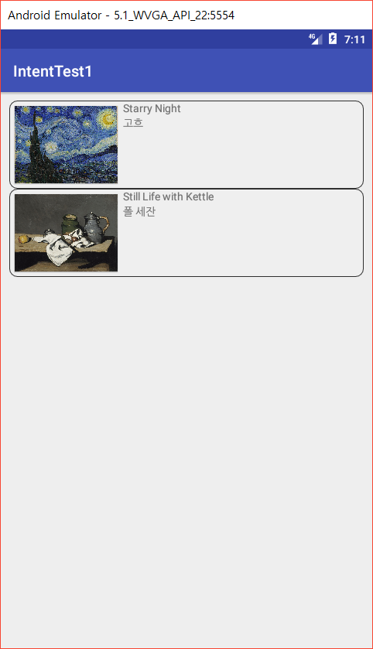 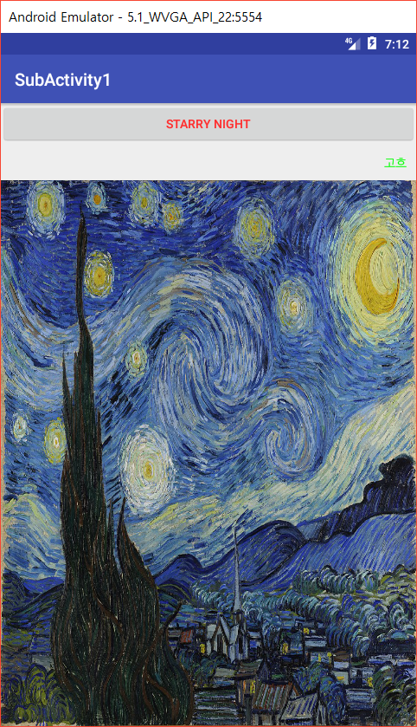

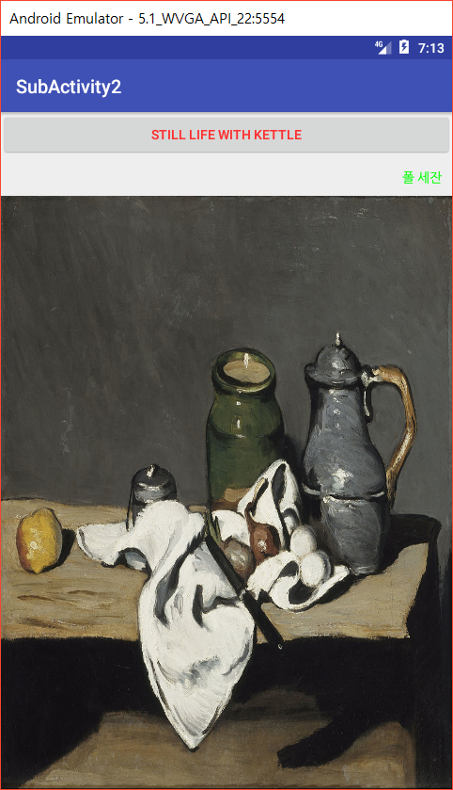

스마트폰프로그래밍

Assign #6

(과제명 : IntentTest2 연습)

학번 : 2013305019

성명 : 김 지 민

제출일자 : 2017. 10. 19

본인은 타인이나 다른 매체를 도용하지 않았음을 확인합니다 <본인사인>

MainActivity.java

**package** com.example.kimji_min.assignment6;  
  
**import** android.content.Intent;  
**import** android.os.Bundle;  
**import** android.support.v7.app.AppCompatActivity;  
**import** android.view.View;  
**import** android.widget.Button;  
**import** android.widget.EditText;  
**import** android.widget.RadioButton;  
**import** android.widget.Toast;  
  
**public class** MainActivity **extends** AppCompatActivity {  
 **static final int *GET_STRING*** = 1;  
 **int result** = 0;  
  
 @Override  
 **protected void** onCreate(Bundle savedInstanceState) {  
 **super**.onCreate(savedInstanceState);  
 setContentView(R.layout.***activity_main***);  
  
 Button button1 = (Button)findViewById(R.id.***button1***);  
 button1.setOnClickListener(**new** View.OnClickListener() {  
 @Override  
 **public void** onClick(View view) {  
 Intent in = **new** Intent(MainActivity.**this**, SubActivity.**class**);  
 startActivityForResult(in, ***GET_STRING***);  
 }  
 });  
 }  
  
 **protected void** onActivityResult(**int** requestCode, **int** resultCode, Intent data) {  
 EditText text1 = (EditText)findViewById(R.id.***text1***);  
 EditText text2 = (EditText)findViewById(R.id.***text2***);  
 RadioButton rb1 = (RadioButton)findViewById(R.id.***add***);  
 RadioButton rb2 = (RadioButton)findViewById(R.id.***sub***);  
 RadioButton rb3 = (RadioButton)findViewById(R.id.***mul***);  
 RadioButton rb4 = (RadioButton)findViewById(R.id.***div***);  
  
 **int** input1 = Integer.*parseInt*(text1.getText().toString());  
 **int** input2 = Integer.*parseInt*(text2.getText().toString());  
  
 **if**(requestCode == ***GET_STRING***){  
 **if**(resultCode == ***RESULT_OK***){  
 **if**(rb1.isChecked()){  
 **result** = input1 + input2;  
 }  
 **else if**(rb2.isChecked()){  
 **result** = input1 - input2;  
 }  
 **else if**(rb3.isChecked()){  
 **result** = input1 * input2;  
 }  
 **else if**(rb4.isChecked()){  
 **result** = input1 / input2;  
 }  
 Toast.*makeText*(getApplicationContext(), **"결과 = "** + Integer.*toString*(**result**), Toast.***LENGTH_SHORT***).show();  
 }  
 }  
 }  
}

SubActivity.java

**package** com.example.kimji_min.assignment6;  
  
**import** android.content.Intent;  
**import** android.os.Bundle;  
**import** android.support.v7.app.AppCompatActivity;  
**import** android.view.View;  
**import** android.widget.Button;  
  
*/**  
 * Created by Kim Ji-min on 2017-10-14.  
 */***public class** SubActivity **extends** AppCompatActivity {  
  
 @Override  
 **protected void** onCreate(Bundle savedInstanceState) {  
 **super**.onCreate(savedInstanceState);  
 setContentView(R.layout.***sub***);  
  
 Button button = (Button)findViewById(R.id.***go_back***);  
 button.setOnClickListener(**new** View.OnClickListener() {  
 @Override  
 **public void** onClick(View view) {  
 Intent in = **new** Intent();  
 setResult(***RESULT_OK***, in);  
 finish();  
 }  
 });  
  
 }  
}

activity_main.xml

*<?***xml version="1.0" encoding="utf-8"***?>*<**LinearLayout xmlns:android="http://schemas.android.com/apk/res/android"  
 xmlns:app="http://schemas.android.com/apk/res-auto"  
 xmlns:tools="http://schemas.android.com/tools"  
 android:layout_width="match_parent"  
 android:layout_height="match_parent"  
 android:orientation="vertical"  
 tools:context="com.example.kimji_min.assignment6.MainActivity"**>  
  
 <**EditText  
 android:id="@+id/text1"  
 android:layout_width="match_parent"  
 android:layout_height="wrap_content"** />  
 <**EditText  
 android:id="@+id/text2"  
 android:layout_width="match_parent"  
 android:layout_height="wrap_content"** />  
 <**RadioGroup  
 android:layout_width="wrap_content"  
 android:layout_height="wrap_content"**>  
 <**RadioButton  
 android:id="@+id/add"  
 android:layout_width="wrap_content"  
 android:layout_height="wrap_content"  
 android:text="더하기"**/>  
 <**RadioButton  
 android:id="@+id/sub"  
 android:layout_width="wrap_content"  
 android:layout_height="wrap_content"  
 android:text="빼기"**/>  
 <**RadioButton  
 android:id="@+id/mul"  
 android:layout_width="wrap_content"  
 android:layout_height="wrap_content"  
 android:text="곱하기"**/>  
 <**RadioButton  
 android:id="@+id/div"  
 android:layout_width="wrap_content"  
 android:layout_height="wrap_content"  
 android:text="나누기"**/>  
 </**RadioGroup**>  
 <**Button  
 android:id="@+id/button1"  
 android:layout_width="match_parent"  
 android:layout_height="wrap_content"  
 android:text="계산하기"**/>  
  
</**LinearLayout**>

sub.xml

*<?***xml version="1.0" encoding="utf-8"***?>*<**LinearLayout xmlns:android="http://schemas.android.com/apk/res/android"  
 android:orientation="vertical" android:layout_width="match_parent"  
 android:layout_height="match_parent"**>  
 <**Button  
 android:id="@+id/go_back"  
 android:layout_width="match_parent"  
 android:layout_height="wrap_content"  
 android:text="돌아가기"**/>  
</**LinearLayout**>

